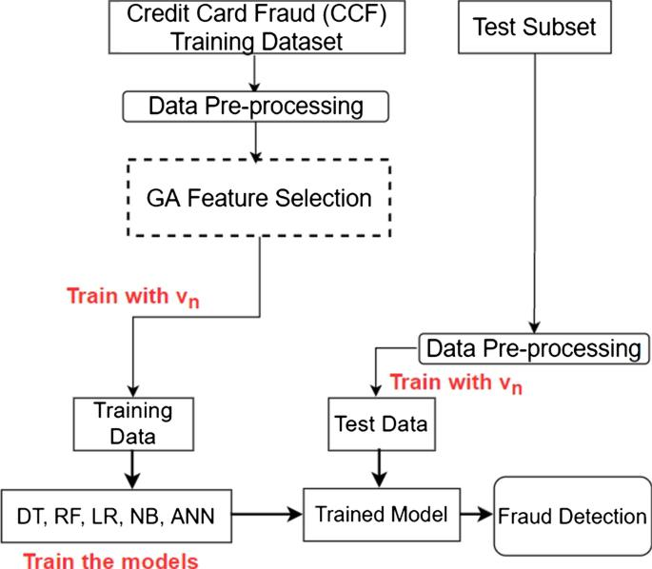

These are simple steps to how to find the Credit Card Fraud Detection

**DATA SOURCE :**

In credit card fraud detection using data science, the primary data source is typically a dataset containing transaction data. Here are the key data sources used in this type of project:

* **Transaction Data :** This is the most critical data source. It includes details of each credit card transaction, such as:

- Transaction amount

- Timestamp (date and time of the transaction)

- Merchant information (merchant ID, location, category)

- Card details (credit card number, expiration date)

* **Historical Data :** 
  + Historical transaction data is used to train machine learning models. It provides a basis for the model to learn patterns of legitimate and fraudulent transactions.
  + The data sets are used to find the detection using kaggle website datasets

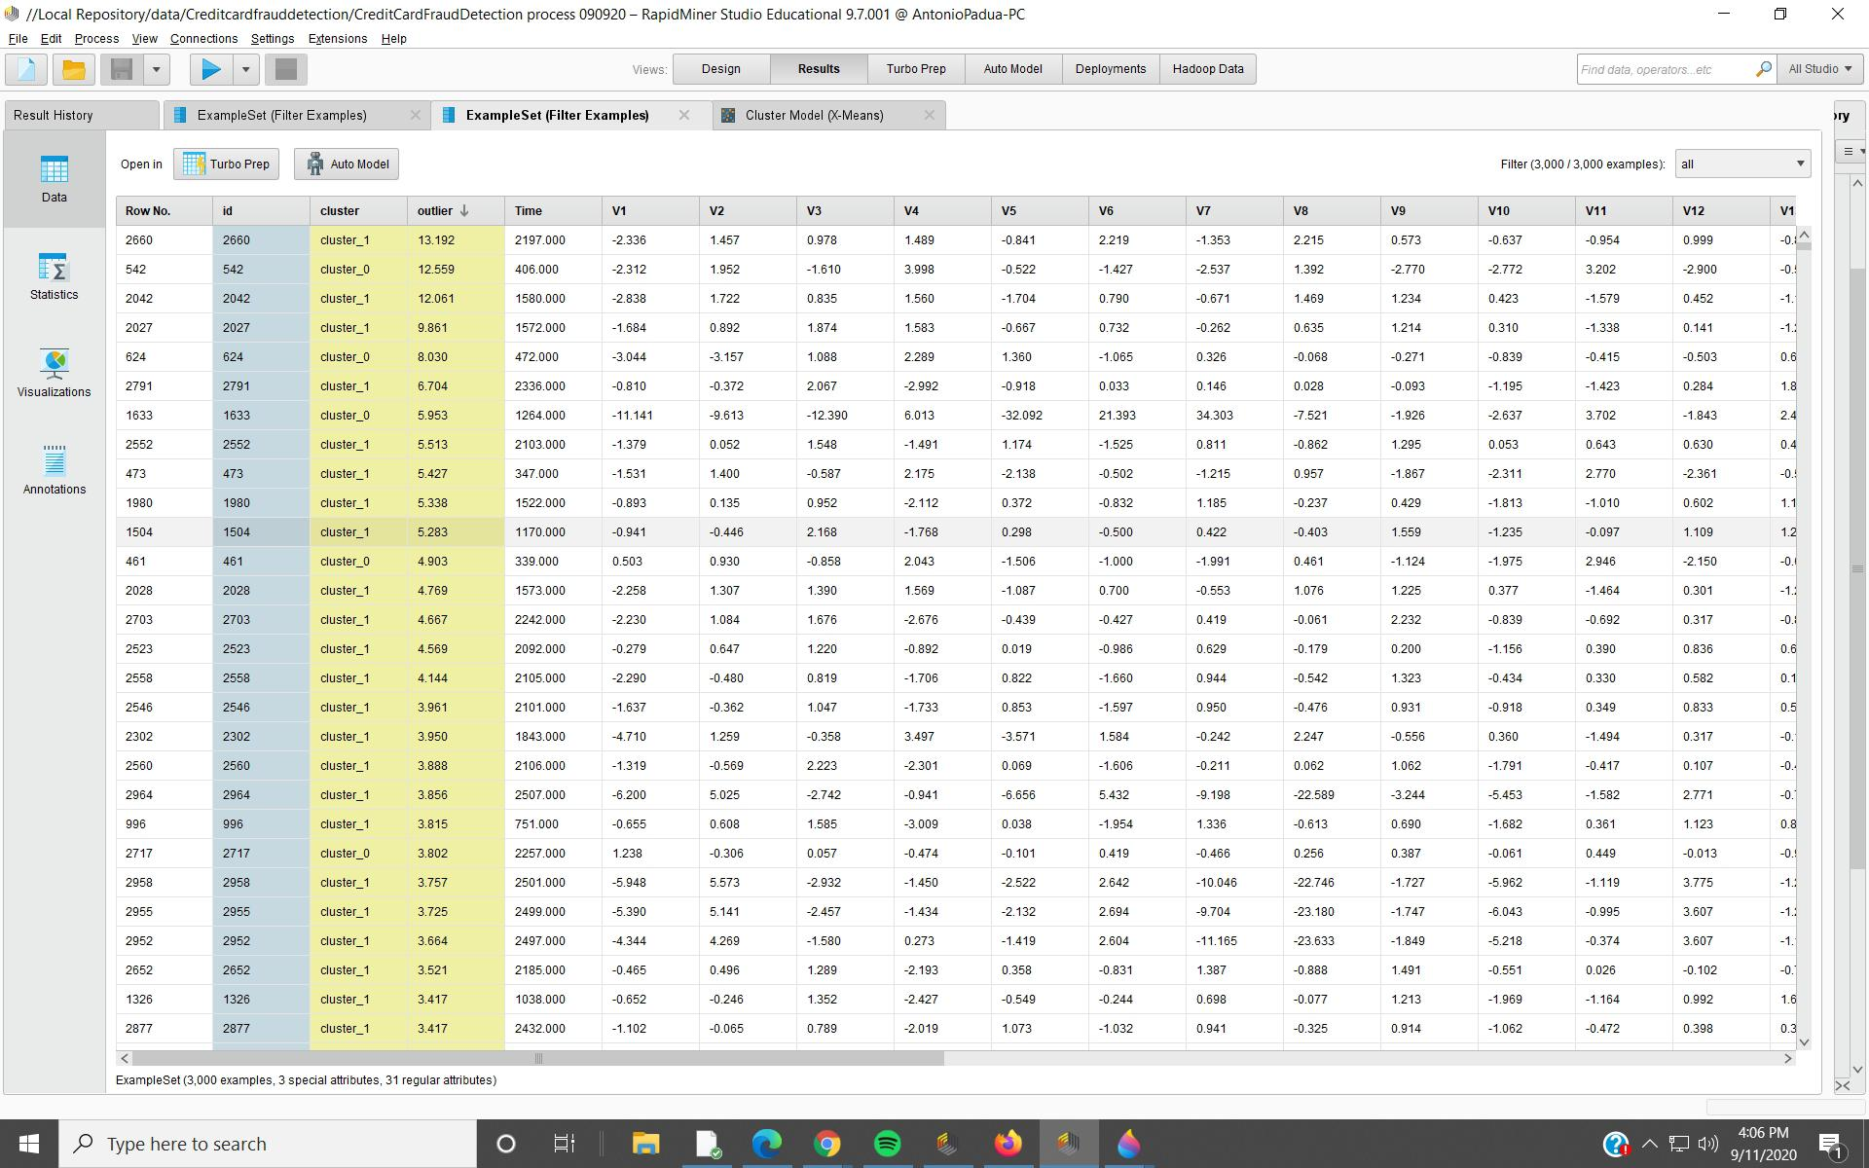

* **Label Data :**  This dataset includes labels or tags that specify whether each transaction is fraudulent or not. Labeling can be done manually by fraud analysts or through historical fraud data.
* **Customer Information :** While not always included, customer data can be useful in fraud detection. It may include details such as customer demographics, transaction history, and account status.
* **External Data :** Some projects incorporate external data sources to enhance fraud detection. This could include data from third-party fraud detection services, economic indicators, or geolocation data.
* **Derived Features :** Engineers often create additional features from the raw data to help improve model performance. Examples include aggregations of transaction history for a given card, features based on transaction timestamps, and more.
* **Blacklists and Whitelists :** Lists of known fraudulent or legitimate entities (e.g., credit card numbers, merchant Ids) are sometimes used to flag or filter transactions.
* **Behavioral Data :** Information about a cardholder’s typical behavior can be useful. This might include the usual transaction amount, frequency, and locations.
* **Authentication Data :** Data related to how a transaction was authenticated, such as whether it required two-factor authentication or a PIN.
* **Anomaly Scores :** Some fraud detection systems generate anomaly scores for transactions based on various features. These scores can be used to rank transactions by their likelihood of being fraudulent.
* **DATA MODEL :** We use the **logistics Regression Model** to find the fraud detection using data set .
* ***Regression –*** Regression is a statistical method used in finance, investing, and other disciplines that attempts to determine the strength and character of the relationship between one dependent variable (usually denoted by Y) and a series of other variables (known as independent variables).
* Regression captures the correlation between variables observed in a data set and quantifies whether those correlations are statistically significant or not.
* ***Logistic Regression* –** Logistic regression is a data analysis technique that uses mathematics to find the relationships between two data factors. It then uses this relationship to predict the value of one of those factors based on the other. The prediction usually has a finite number of outcomes, like yes or no.

**---** In this we used to import the Logistic regression Model  **from sklearn.logistic_model import LogisticRegression**

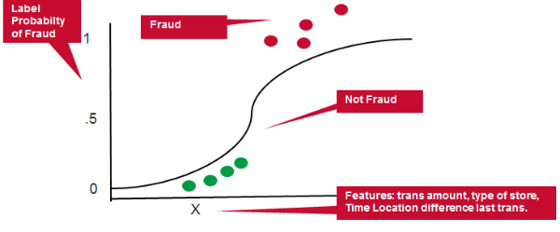

Logistic Regression Graph For **Credit Card Fraud Detection**

It’s important to note that data privacy and security are paramount in handling such sensitive financial data. Compliance with regulations like PCI DSS (Payment Card Industry Data Security Standard) and ensuring the anonymity of personal information are critical considerations in the use of these data sources.

**DATA PREPROCESSING :**

Data preprocessing is a crucial step in credit card fraud detection using data science. It helps ensure that the data you feed into your machine learning model is clean, standardized, and ready for analysis. Here are the common data preprocessing steps for this types :

**Handling Missing Values :**

- Identify and assess missing values in the dataset. Missing values can occur in various fields like merchant information or card details.

- Decide on an appropriate strategy to handle missing values. Common approaches include imputation (filling in missing values with statistical measures like mean or median) or removing rows or columns with too many missing values.

- In this use the method to find the Missing Values are NaN values is **data.isnull().values.any()**

* **Data Cleaning :**

- Check for and address data anomalies or errors, such as outliers that might indicate fraudulent transactions or incorrect entries.

- Remove duplicates if they exist in the dataset.

- Removing Missing values and NaN values .

* **Data Transformation :**

- Convert categorical variables into numerical format using techniques like one-hot encoding or label encoding, especially for features like merchant information or card details.

- Normalize or scale numerical features to ensure they have similar scales. Common methods include Min-Max scaling or z-score standardization.

* **Handling Imbalanced Data :**

- Credit card fraud datasets often suffer from class imbalance, with a significantly higher number of non-fraudulent transactions compared to fraudulent ones. Address this issue using techniques like oversampling (creating more instances of the minority class), undersampling (reducing instances of the majority class), or using advanced methods like Synthetic Minority Over-sampling Technique (SMOTE).

**Feature Engineering :**

- Create relevant features that may aid in fraud detection. For example, calculate transaction frequency, average transaction amount, or time-based features like the hour of the day or the day of the week.

* **Data Splitting :**

- Split the dataset into training and testing sets. The training set is used to train your machine learning model, while the testing set is used to evaluate its performance.

* **Handling Time-based Data :**

- If your dataset includes timestamps, consider converting them into useful features, such as time since the last transaction or time of day features.

* **Data Scaling :**

- Normalize numerical features to ensure that they have similar scales. This can help improve the performance of some machine learning algorithms.

* **Data Privacy and Security** :

- Implement data privacy measures to protect sensitive information, such as credit card numbers. This may involve tokenization, encryption, or anonymization of data.

These preprocessing steps are essential to prepare the data for machine learning algorithms, ensuring that they can effectively learn from it and make accurate predictions about whether a transaction is fraudulent or not. The specific steps you take will depend on the characteristics of your dataset and the machine learning algorithms you plan to use.